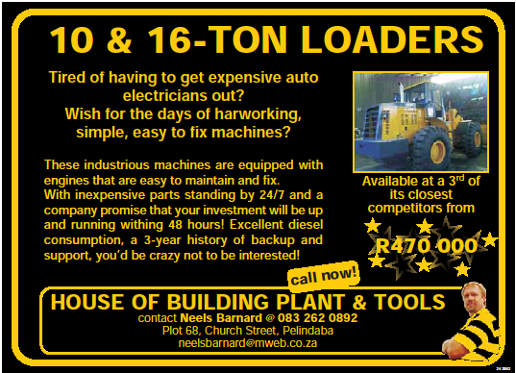

**Q & A:**

**Will this be an investment?**

Yes at 1/3 of the cost of the competitors. They are simplistic hard working and affordable.

Your profit will dus start much earlier and you could grow your business in no time.

The loaders are easy to maintain with a full team of experts for backup.

**What type of engines do they use?**

Please see specifications. The engines are well known in the Truck market and have proven itself over the years. We also use water cool hydraulics and transmission.

**What is the diesel consumption?**

This is an excellent consumption of approximately 12 liters per hour.

**Is the loader reliable?**

Yes, yes. These loaders are made in China. They are currently 30 years in production with an industry capacity of between 150-200 units per month.

Our factory in China receive an award from the Chinese Government for outstanding product as well as an award for outstanding Product for Export.

Our loaders are also approved by the Chinese Bureau of Standard and are SABS approved.

**What is the cost of the loaders?**

R470 000.00 for the CXX939 Loader and R670 000.00 for the CXX955-11 loader.

**Are the loaders hard to fix?**

No, we don’t use any electronics in our loaders.

So there is no need for a specialized mechanic. Or some specialized tools to fix the loader.

The transmission is a winner. It consists only of a working gear, a driving gear and a reverse gear.

The transmition is based on “Clark” model.

We don’t have any major break downs on any of our loaders that we sold in the last 3 years.

**Will there be spare parts and will it be affordable?**

This will be another place where we will exhale. Parts are very affordable and we will have part to you anywhere within 48 hours. Service is part of our promise to you.

**Do you have a warrantee on the loaders?**

1500 hours or 1 year whichever comes first.

**Will we be here in the future?**

Yes, for sure. We have sold over 150 machines in SA over the past 3 years.

So we feel that we build an excellent name and will provide a great service.

We are settled in South-Africa with all the spare parts, trained and qualified mechanics for your convenience 24 hours a day, 7 days a week.

**Our promise:**

1. Service! Service! Service!
2. A high quality product at a reasonable price
3. Comprehensive spare parts stock at all times

**What does services cost and when does the loaders need to be serviced?**

**(Please note this is subject to change)**

|  |  |  |  |  |
| --- | --- | --- | --- | --- |
| **Service Guide** | |  |  |  |
|  |  |  |  |  |
|  | **Qty** | **Description** | **Unit Price** | **Total** |
| **500 Hour Service** | 25 | Liter Engine Oil (15W40) | 25.75 | 643.75 |
|  | 10 | Liter Antifreeze | 42.69 | 426.90 |
|  | 2 | Oil Filters | 165.00 | 330.00 |
|  | 2 | Diesel Filters | 180.00 | 360.00 |
|  | 1 | Air Filter | 216.00 | 216.00 |
|  | 1 | Alternator Belt | 180.00 | 180.00 |
|  | 1 | Fan Belt | 273.00 | 273.00 |
|  |  |  |  | **2,429.65** |
|  |  |  |  |  |
|  | 3 | Hours Labor (Estimate Only) | 350.00 | 1,050.00 |
|  |  | Travelling (there and back) | 3.50 / km |  |
|  |  |  |  |  |
|  | **Qty** | **Description** | **Unit Price** | **Total** |
| **1000 Hour Service** | 25 | Liter Engine Oil (15W40) | 25.75 | 643.75 |
|  | 45 | Liter Transmission Oil (15W40) | 25.75 | 1,158.75 |
|  | 70 | Liter Diff Oil (85W140) | 26.45 | 1,851.50 |
|  | 10 | Liter Antifreeze | 42.69 | 426.90 |
|  | 2 | Oil Filters | 165.00 | 330.00 |
|  | 2 | Diesel Filters | 180.00 | 360.00 |
|  | 1 | Air Filter | 216.00 | 216.00 |
|  | 1 | Alternator Belt | 180.00 | 180.00 |
|  | 1 | Fan Belt | 273.00 | 273.00 |
|  |  |  |  | **5,439.90** |
|  |  |  |  |  |
|  | 5 | Hours Labor (Estimate Only) | 350.00 | 1,750.00 |
|  |  | Travelling (there and back) | 3.50 / km |  |
|  |  |  |  |  |
|  | **Qty** | **Description** | **Unit Price** | **Total** |
| **1500 Hour Service** | 25 | Liter Engine Oil (15W40) | 25.75 | 643.75 |
|  | 10 | Liter Antifreeze | 42.69 | 426.90 |
|  | 2 | Oil Filters | 165.00 | 330.00 |
|  | 2 | Diesel Filters | 180.00 | 360.00 |
|  | 1 | Air Filter | 216.00 | 216.00 |
|  | 1 | Alternator Belt | 180.00 | 180.00 |
|  | 1 | Fan Belt | 273.00 | 273.00 |
|  |  |  |  | **2,429.65** |
|  |  |  |  |  |
|  | 5 | Hours Labor (Estimate Only) | 350.00 | 1,750.00 |
|  |  | Travelling (there and back) | 3.50 / km |  |
|  |  |  |  |  |
|  | **Qty** | **Description** | **Unit Price** | **Total** |
| **3000 Hour Service** | 25 | Liter Engine Oil (15W40) | 25.75 | 643.75 |
|  | 45 | Liter Transmission Oil (15W40) | 25.75 | 1,158.75 |
|  | 70 | Liter Diff Oil (85W140) | 26.45 | 1,851.50 |
|  | 240 | Liter Hydraulic Oil | 20.05 | 4,812.00 |
|  | 10 | Liter Antifreeze | 42.69 | 426.90 |
|  | 2 | Oil Filters | 165.00 | 330.00 |
|  | 2 | Diesel Filters | 180.00 | 360.00 |
|  | 1 | Air Filter | 216.00 | 216.00 |
|  | 1 | Alternator Belt | 180.00 | 180.00 |
|  | 1 | Fan Belt | 273.00 | 273.00 |
|  |  |  |  | **10,251.90** |
|  |  |  |  |  |
|  | 6 | Hours Labor (Estimate Only) | 350.00 | 2,100.00 |
|  |  | Travelling (there and back) | 3.50 / km |  |